DIRECT GEOSTATISTICAL SIMULATION ON UNSTRUCTURED GRIDS

JOHN MANCHUK, OY LEUANGTHONG and CLAYTON V. DEUTSCH
Department of Civil & Environmental Engineering, 220 CEB,
University of Alberta, Canada, T6G 2G7

Abstract. Unstructured grids are commonly used in reservoir modeling and are being increasingly considered in complex mining engineering applications. Block kriging of the attributes can be easily implemented; however, this implicitly assumes linear averaging, which is not the case after Gaussian transformation or with variables such as permeability. Direct simulation has been proposed as a solution; however, there are a number of important implementation considerations. This paper addresses the following considerations: (1) search for nearby relevant block and point data, (2) stabilization of the kriging equations and weights in presence of complex screening, (3) correction of the homoscedastic kriging variance to account for realistic proportional effect, (4) determination of valid conditional distribution shapes, (5) accounting for geological controls including stratigraphic surfaces and mixture of multiple facies within an unstructured grid block, and (6) accounting for directional permeability that does not average linearly. Direct simulation on unstructured grids is made practical by addressing these six considerations.

1 Introduction

Unstructured grids are used to model the complex geology and geometry of reservoirs and to provide better accuracy to important development areas. For example, tartan grids are used to provide a high cell density near wells and low cell density in less influential areas (Tran, 1995).

Sequential Gaussian simulation (SGS) (Isaaks, 1990) has become the most extensively used algorithm for continuous variable simulation; however, it is impractical when considering multiscale data, particularly when the data do not average linearly. Direct sequential simulation (DSS) (Xu and Journel, 1994) is an attractive alternative due to the increasing popularity of unstructured grids and the need to integrate multiscale data.

One advantage of DSS is that a wide variety of volume supports can be integrated. This requires that kriging is based on mean covariance/variogram values. There are various ways in which mean covariance calculations can be made more efficient (Pyrcz and Deutsch, 2002). While computational efficiency in this regard is important, an efficient search for nearby relevant data is just as important for practical implementation. The popular method when dealing with regular grids is the super block search strategy, a variation of which could be applied to unstructured grids; however, it may be advantageous to consider different search tree algorithms that may be more efficient.

The effects of screening remain an issue in the case of multiscale data. Proper filtering of data prior to kriging may be required to avoid anomalously high weights that may lead to extreme estimates. Some filtering techniques such as the octant search, iterative kriging, and the template technique have been used to mitigate screening.

The use of simple kriging (SK) results in an estimation variance that is independent of the data values; this independence is referred to as homoscedasticity. Unfortunately, real data may exhibit a heteroscedastic feature known as the proportional effect, wherein the local mean and variance are often quadratically related (Journel and Huijbreghts, 1978). This heteroscedasticity must be accounted for. An advantage of SK is that covariance reproduction only requires that the mean and variance of this distribution be defined by the SK mean and variance (Journel, 1994). A method of determining the local distribution shapes has been developed and will be revisited (Pyrcz and Deutsch, 2002; Deutsch et al, 2001; Oz et al, 2001).

The advantage of unstructured grids in capturing more complex geology also entails further complications related to geological controls such as stratigraphic surfaces and a mixture of multiple facies that may be represented within any particular block. An unstructured grid may not conform to the stratigraphic setting, which introduces problems relating to selecting relevant data for kriging and estimating grid blocks that contain multiple subsequence layers.

Further, the use of average variogram/covariance values in SK (inside DSS) for multiscale data has an implicit assumption of linear averaging of the model variables. This poses a problem when the variable of interest does not average linearly. Permeability is a classic example of such a variable. Accounting for the appropriate type of averaging is integral to the correct implementation of DSS.

This paper addresses these six important issues and proposes some novel approaches for resolution.

2 Search for Nearby Relevant Block and Point Data

When considering unstructured grids, data may consist of original data at a small scale, regularly gridded soft data, and grid blocks of varying sizes. There are several methods that can be used to deal with this array of data: A brute force method involving a matrix of distances n_{GB} by n_{GB} in size, where n_{GB} is the number of grid blocks; A super block search strategy (Deutsch and Journel, 1998); or the use of search trees. The brute force method is only applicable to small problems as larger data sets would be impractical for conventional computer memory availability. A super block strategy could be used; however, implementing certain types of search trees will be more efficient.

One type of search trees common in the computer graphics and computer gaming industry are quadtrees and octrees, (Figure 1) (Frisken and Perry, 2002). When considering graphics visualization, these search trees are used to quickly determine which polygons are in view such that only those polygons are drawn (this reduces memory requirements). Searching for nearest neighboring data is a similar task.

Quadtrees and octrees organize data in such a way that point location, region location, and nearest neighbor operations can be done easily. Frisken and Perry (2002) introduce a binary indexing system for quadtrees that allows for efficient execution of the above operations. This system can easily be applied to octrees for three dimensional data as well.

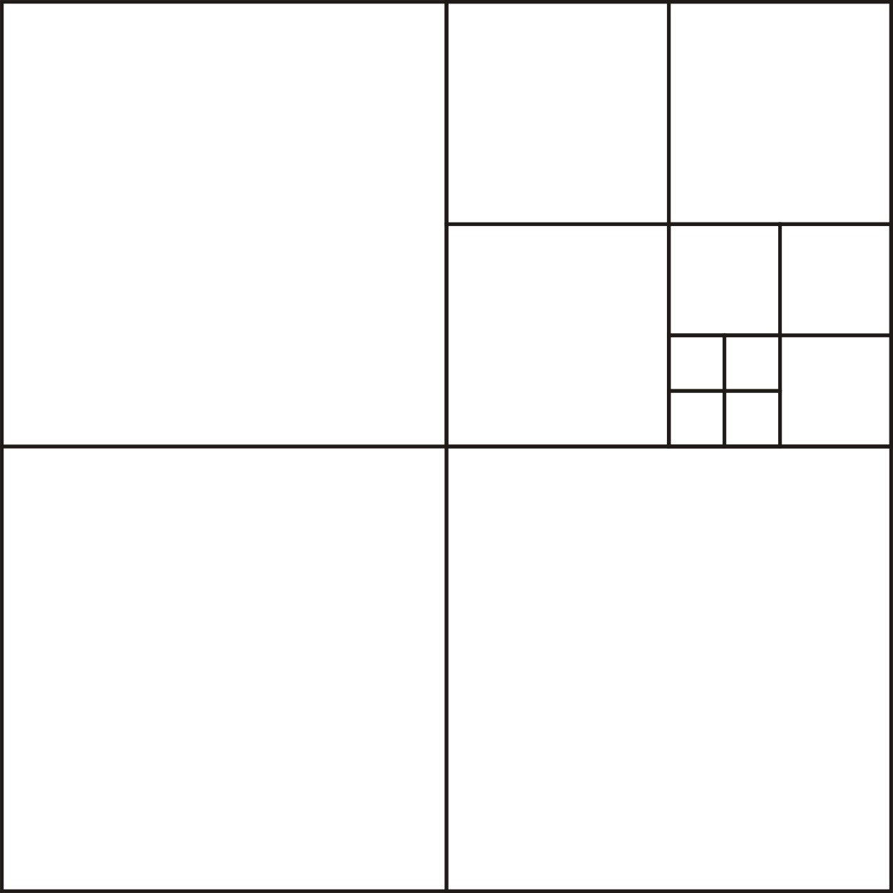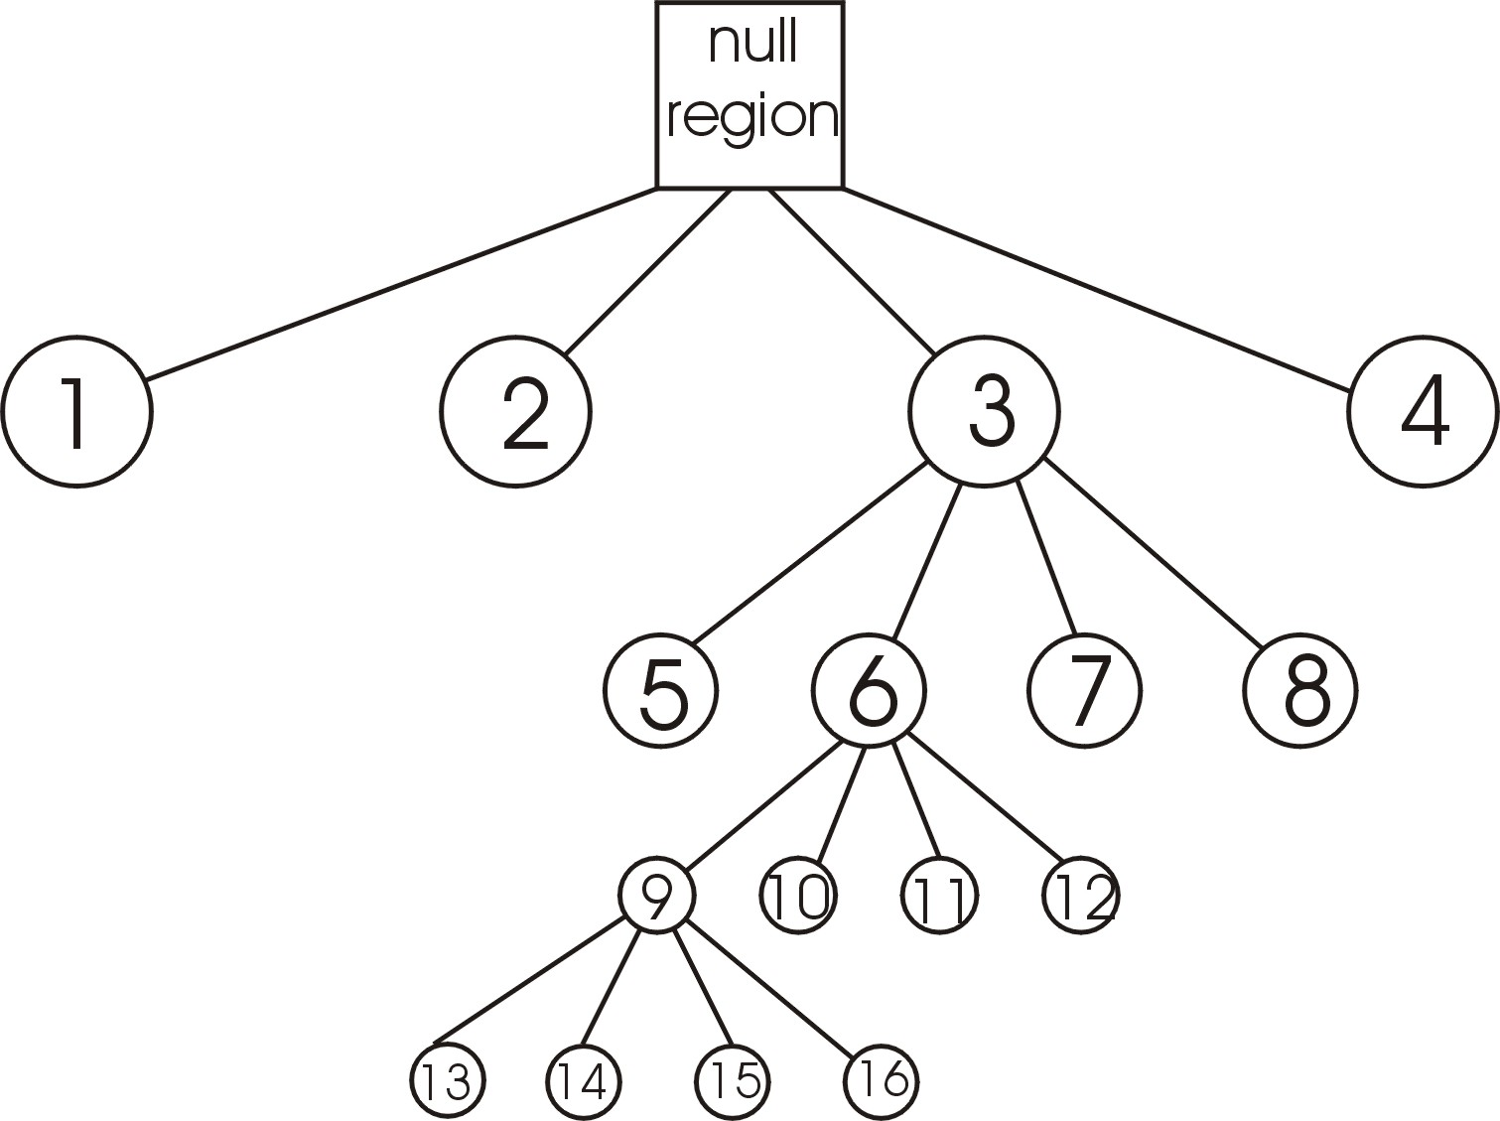
Figure 1: Example of a quadtree structure (left) and tree-representation (right). The quadtree is more refined in areas with higher data densities.

Implementing quadtrees or octrees to organize spatial data for simulation purposes allows for efficient acquisition of nearby data for each node to be simulated. The search for nearest neighboring leaf nodes is not dependant on the type of grid and tree traversal for finding and inserting points is a simple process. Having these characteristics along with low memory requirements makes search trees excellent for unstructured grid problems.

3 Stabilization of the Kriging Equations and Weights in the Presence of Complex Screening

Screening can cause extreme positive and negative weights that lead to erroneous estimates and estimation variances. One method of reducing the occurrence of extreme weights is to remove data from the kriging matrix: this iterative kriging technique will remove data until the absolute value of all the weights are below a specified maximum. Iterative kriging works; however, data that may be highly influential in estimating a location could be removed from the kriging matrix resulting in a less accurate result. Another method of reducing screening is the template technique which involves rejecting any data that are shadowed by a closer data (Figure 2). A downfall to the template technique is its high demand on computation time.

A new method of filtering data used in estimating a location is the sector search method, which is somewhat similar to the template technique. The sector search method uses input dip and azimuth tolerances to create sectors in which only the nearest data is selected for kriging (Figure 2).

The sector search subroutine works fast in two dimensions as the sectors are all pre-constructed and then translated to locations of interest; however, in three dimensions, the sectors are built as points are encountered making the process more time consuming.

Even though the sector search method removes many screened data, there may be unreasonable screening still present. For example, consider two points in adjacent sectors, the point closer to the location being estimated will screen the effect of the second point. Using larger sectors will keep screening to a minimum.

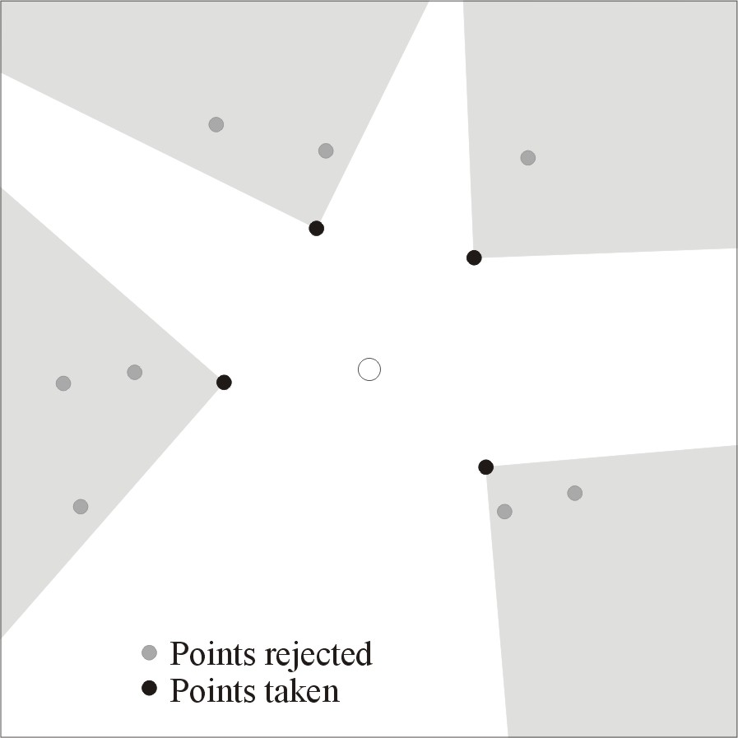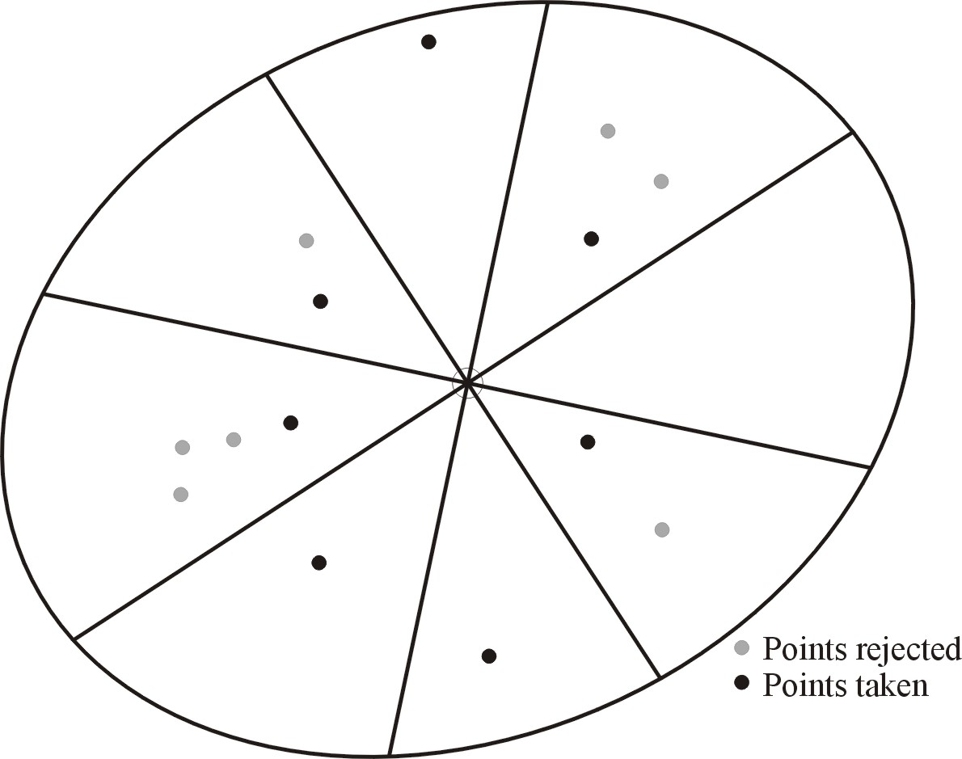

Figure 2: The template technique (left) and the sector search method (right) to reduce screening.

4 Correction of the homoscedastic kriging variance to account for realistic proportional effect

Data in original units are often heteroscedastic. High valued areas are more variable. This heteroscedastic behavior is commonly referred to as the proportional effect (Journel and Huijbregts, 1978). DSS relies on covariance reproduction through local distributions whose mean and variance are defined by SK (Xu and Journel, 1994). For data following the congenial Gaussian distribution this assumption is correct; however for data exhibiting heteroscedastic features, it is an unsuitable assumption due to the homoscedasticity of the kriging variance. The kriging variance must be adjusted such that the proportional effect is reproduced.

4.1 DSS USING LOGNORMAL DATA

To see the effects of directly simulating data that exhibit the proportional effect, a study was performed using a lognormal distribution. This distribution was chosen for a number of reasons: (1) although real data are not necessarily lognormal, most data exhibit a strong asymmetry similar to that characterized by the lognormal distribution, and (2) there is a clear mathematical link between the lognormal and the more common Gaussian distribution that permits tractability of the results. Further, an equation describing the proportional effect of lognormal data exists (Journel and Huijbregts, 1978). Knowing these relations, the kriging variance can be calibrated to honor the heteroscedasticity inherent in lognormal data.

An exhaustive lognormal data set was generated by transforming an unconditional Gaussian model (Figure 3). The mean and variance of the lognormal data were arbitrarily chosen to be 100 and 10000, respectively. A set of 625 samples was drawn from the model and used for numerical experimentation.

4.1.1 Options of Simulation Explored

Three options were identified for evaluation:
Option 1 Perform SGS
Option 2 Perform DSS without correcting the kriging variance
Option 3 Perform DSS and correct the kriging variance to honor the proportional effect

With lognormal data, an equation exists for correcting the variance using the mean or estimate:
$$σ_{Z,C}^{2}={\left[z^{}(u)\right]}^{2}(e^{β_{G}^{2}⋅σ_{Y}^{2}}−1)$$
Where is the corrected variance, is the local variance in normal space, and is the global variance of ln(Z). By determining a relation between the estimation variance in Gaussian space and that in lognormal space, the value of could be determined without having to perform kriging twice.

For each option, 100 realizations were generated and the E-type mean and variance was calculated (Figure 4). Reproduction of the global statistics and the variogram were verified. Figure 4 also shows similar results between DSS with a correction and SGS; however, with DSS and no correction as in Option 2, the variance is clearly homoscedastic. A more visual comparison of the three options is available in Figure 5 where the spatial distribution of the mean and standard deviation show reproduction of the proportional effect in a single realization.
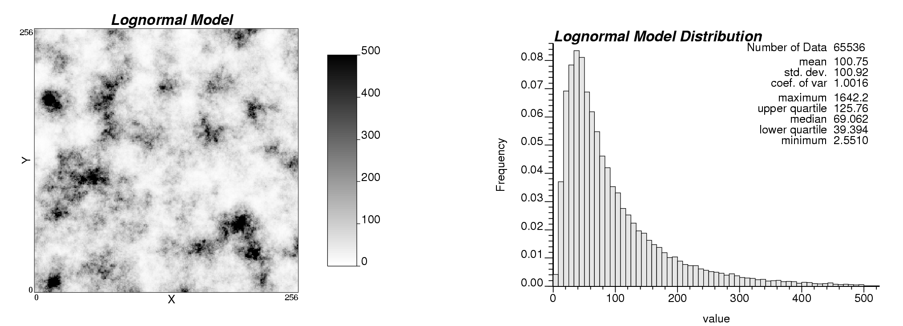
Figure 3: The lognormal model used for direct simulation experimentation.

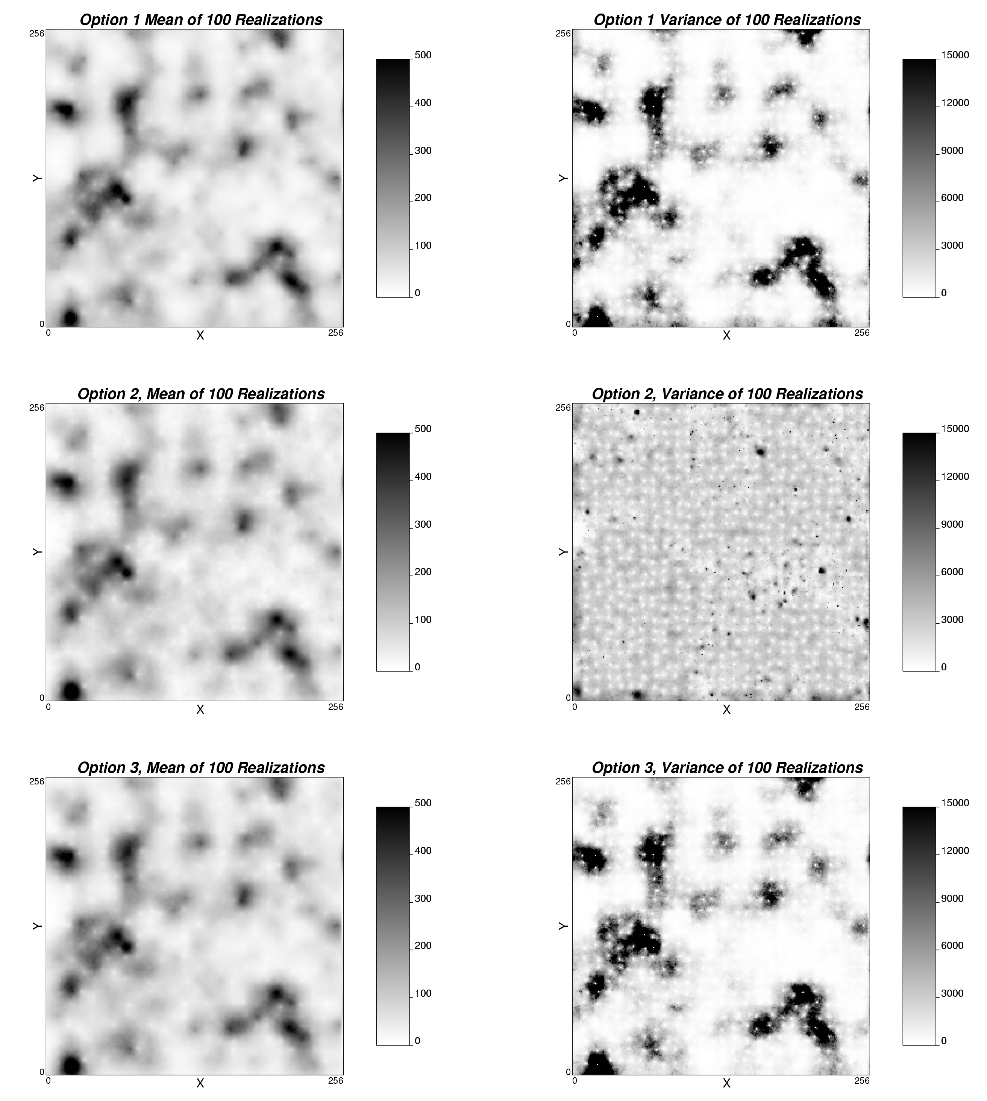
Figure 4: The mean and variance taken over 100 realizations for all three simulation approaches: Option 1 is the straightforward SGS, Option 2 refers to DSS, and Option 3 refers to DSS with variance correction to account for heteroscedasticity.

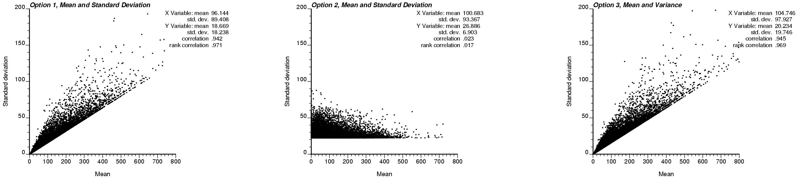
Figure 5: Local mean versus standard deviation at every estimated location for options 1 (left), 2 (middle), and 3 (right). Options 1 and 3 show the proportional effect and compare nicely. Option 2 shows a homoscedastic variance.

By performing simulation using lognormal data, it is possible to introduce a solution for dealing with the proportional effect. The lognormal distribution is particularly useful because the proportional effect is one of its prominent features and is analytically accessible.

We expect that the proportional effect could be fit from real data instead of using either the Gaussian model of no proportional effect of the lognormal model of a quadratic proportional effect.

5 Determination of valid conditional distribution shapes

A method to determine the shape of the local distributions in original units from the SK mean and variance is needed such that the global distribution is reproduced.

Figure 6 shows a numerical integration approach proposed by Oz et. al. (2001). If a specific probability p of a non-standard normal distribution with mean m and standard deviation σ is known, the corresponding direct space quantile can be calculated as:

where G_{{0,1}} is the cumulative distribution function (cdf) of a standard Gaussian distribution, G_{{m,σ}} is the cdf of a non-standard Gaussian distribution with mean m and standard deviation σ, and F is the cdf of the representative data distribution. Z(u) is the p quantile of the local distribution of uncertainty (Pyrcz and Deutsch, 2002).

By creating a series of Y-space distributions from a list of means and variances and repeating the above procedure for a range of quantiles, a set of Z-space distributions can be generated. The mean and variance of each Z-space distribution can be calculated and used as reference values. Upon kriging at a particular location, the resulting mean and variance can be used to look up the corresponding local distribution in original units, from which a simulated value can be drawn.

6 Accounting for geological controls including stratigraphic surfaces and mixture of multiple facies within an unstructured grid block

Some geological settings are characterized by a series of genetically related strata. The geology may consist of a sequence stratigraphic framework; the bounding surfaces between the layers correspond to a specific geologic time that separates two different periods of deposition or a period of erosion followed by deposition (Deutsch, 2002). This presents some potential issues related to the structure such as: the grid does not line up with the stratigraphic surfaces, grid blocks may contain multiple facies and subsequences (Figure 7), and searching for relevant data to estimate unknown locations.

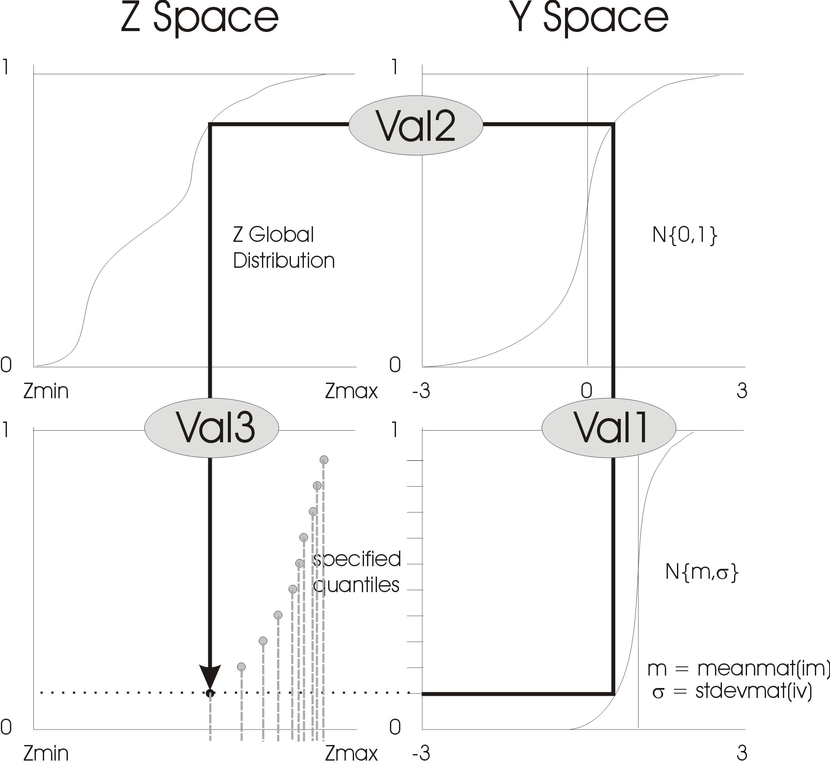
Figure 6: The graphical representation of the transformations applied to calculate the local distributions of uncertainty with a shape such that the global distribution is reproduced. The illustrated transformation is repeated for a sufficient number of quantiles to describe the local distribution.

A possible method of dealing with data within various subsequences is to flag the data by subsequence and only use data within genetically related strata. When simulating blocks that cross multiple subsequences, flagging and simulating its value poses a problem. One idea is to discretize the block into smaller “blocks”, flag the smaller components and estimate them to obtain a value or multiple values and structure within a grid block. Since blocks may cross into multiple subsequences as well as contain multiple facies, a method to determine that portion of a grid block relevant to estimation is required. An idea of the subsequence structure within grid blocks being estimated as well as those being used for conditioning data is critical (Figure 8).

Upon estimating grid blocks, the proportion of facies within each block can be determined overall, but it may be better to retain the facies proportions within each subsequence in a block.

7 Accounting for directional permeability that does not average linearly

Because data exist in vastly different scales such as small core-based permeability and large scale production data, problems arise due to the scale difference and non linear averaging of permeability. By implementing a power law transform, permeability values will approximately average linearly, and can then be used in a direct simulation approach (Zanon et al, 2002).

The general formulae for power law averaging is
$K_{\text{eff}}={\left[\frac{1}{v}\int_{v}{k(u)^{ω}du}\right]}^{\frac{1}{ω}}$
where v is the volume over which the average is calculated, k(u) is the permeability at location u in v, and ω is an averaging exponent.

Since DSS utilizes kriging as an estimator, the model variables must average linearly with scale. By using a power law transformation prior to kriging, the problems generated by multiscale data can be avoided and transformed variables will average linearly with scale. A Gaussian transform would undo the benefit of the power-law transform; it is important to perform kriging and simulation in the correct units.

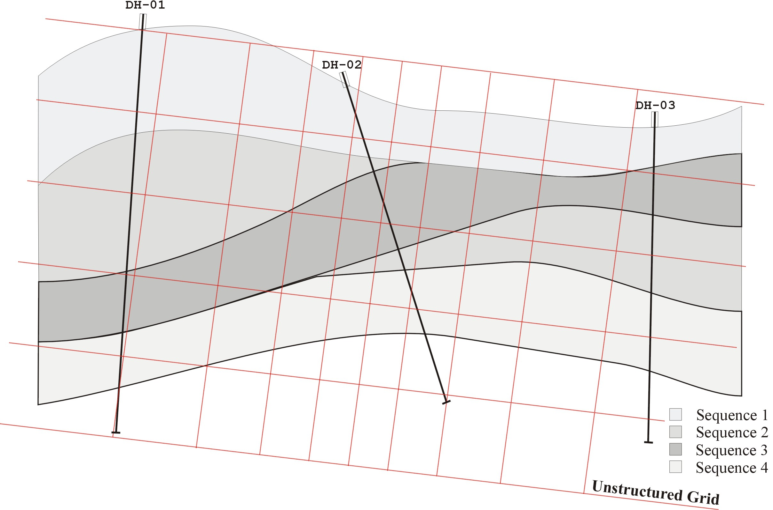
Figure 7: Stratigraphic surfaces and superimposed unstructured grid. Three hypothetical drill holes/wells are also shown.

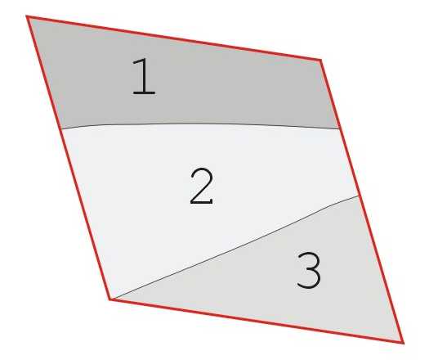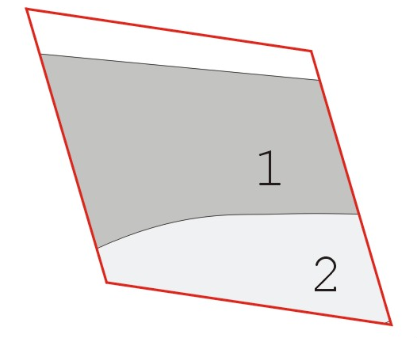
Block 1 Block 2
Figure 8: Unstructured grid block crossing multiple subsequence layers. If block 1 is being estimated using block 2, only data within block 2 and subsequence 1 should be used to estimate data within block 1 subsequence 1.

A concern of implementing power law transformation, especially when dealing with unstructured grids, is that ω may not be constant over every volume support. An unstructured grid may involve many different volume support sizes to be estimated and when the scale difference is large, ω may change. Other concerns that affect the value of ω are arbitrarily chosen boundary conditions and if the formation approaches the percolation threshold (Kirkpatrick, 1973).

8 Conclusions

Unstructured grids are practically relevant for realistic reservoir modeling. The distinction of simulating in the units of the original data provides significant benefits such accounting for multiscale data and permitting different local distributional shapes. In practice, implementation of DSS has been limited. Even something as seemingly straightforward as searching for data is complicated by the multiscale nature of the problem. In these instances, quadtrees or octrees may be particularly efficient. Screening may also lead to destabilization of the kriging matrix, thus a preferential filtering of the data through a sector search may be appropriate. Multiscale issues are further complicated by the very nature of the model variable, whether these variables average linearly or whether pre-processing transform such as the power law transform is required.

Unstructured grids allow for increasingly complex geology to be integrated; however, this presents issues in grid block definition and facies identification if the blocks are too large and/or if they cross multiple sequence or sub-sequence stratigraphic layers. Despite all these issues, perhaps the most important advance presented in this paper is the correction applied to the SK variance to account for the heteroscedastic nature that is often inherent to real data. The lognormal case was used to illustrate a corrective approach to effectively reproduce heteroscedasticity.

References

Deutsch, C.V., Kriging with Strings of Data, Mathematical Geology, Vol. 26, No. 5, 1994.
Deutsch, C.V., Geostatistical Reservoir Modeling, Oxford University Press Inc., 2002.
Deutsch, C.V. and Journel, A.G., GSLIB Geostatistical Software Library and User’s Guide, Second Edition, Oxford University Press, 1998.
Deutsch, C.V. Tran, T. and Xie, Y., A preliminary report on: An approach to ensure histogram reproduction in direct sequential simulation, Technical report, Center for Computational Geostatistics, University of Alberta, Edmonton, AB, March 2001.
Frisken, S.F., and Perry, R.N., Simple and Efficient Traversal Methods for Quadtrees and Octrees, Mitsubishi Electrical Research Laboratories, 2002.
Journel, A.G. and Huijbregts, Ch.J., Mining Geostatistics, Academic Press Limited, 1978.
Kirkpatrick, S., Percolation and Conduction, Reviews of Modern Physics, 1973, Vol. 45, No. 4, pp 574-588
Leuangthong, O. and Deutsch, C.V., Modeling Multivariate Multiscale Data, Center for Computational Geostatistics, University of Alberta, Report 4: 2002.
Oz, B., Deutsch, C.V., Tran, T., and Xie, Y., A fortan 90 program for direct sequential simulation with histogram reproduction, Computers & Geosciences, page submitted 2001.
Tran, T.T., Stochastic Simulation of Permeability Fields and Their Scale-up for Flow Modeling, PhD Thesis, Stanford University, 1995.
Xu, W. and Journel, A.G., DSSIM: A General Sequential Simulation Algorithm, Stanford Center for Reservoir Forecasting, May 1994.
Zanon, S. Nguyen, H. and Deutsch, C.V., Power Law Averaging Revisited, Center for Computational Geostatistics, University of Alberta, Report 4, 2002.

